**Chapter 9 - Plant Reproduction**

**All Lectures Uploaded on YouTube:**

[**https://tinyurl.com/fkm9-biology**](https://tinyurl.com/fkm9-biology)



**9.1. Asexual Reproduction**

Asexual reproduction is a mode of reproduction in which a single parent organism produces new individuals without the involvement of gamete formation or fertilization. The offspring produced are genetically identical to the parent and to each other; such offspring are called clones.

**Key Characteristics Of Asexual Reproduction:**

• Only one parent is involved.

• No formation or fusion of gametes occurs.

• No meiosis takes place.

• Offspring show no genetic variation.

• It is a rapid and energy‑efficient process.

• Common in lower plants and microorganisms.

**9.1.1. Binary Fission**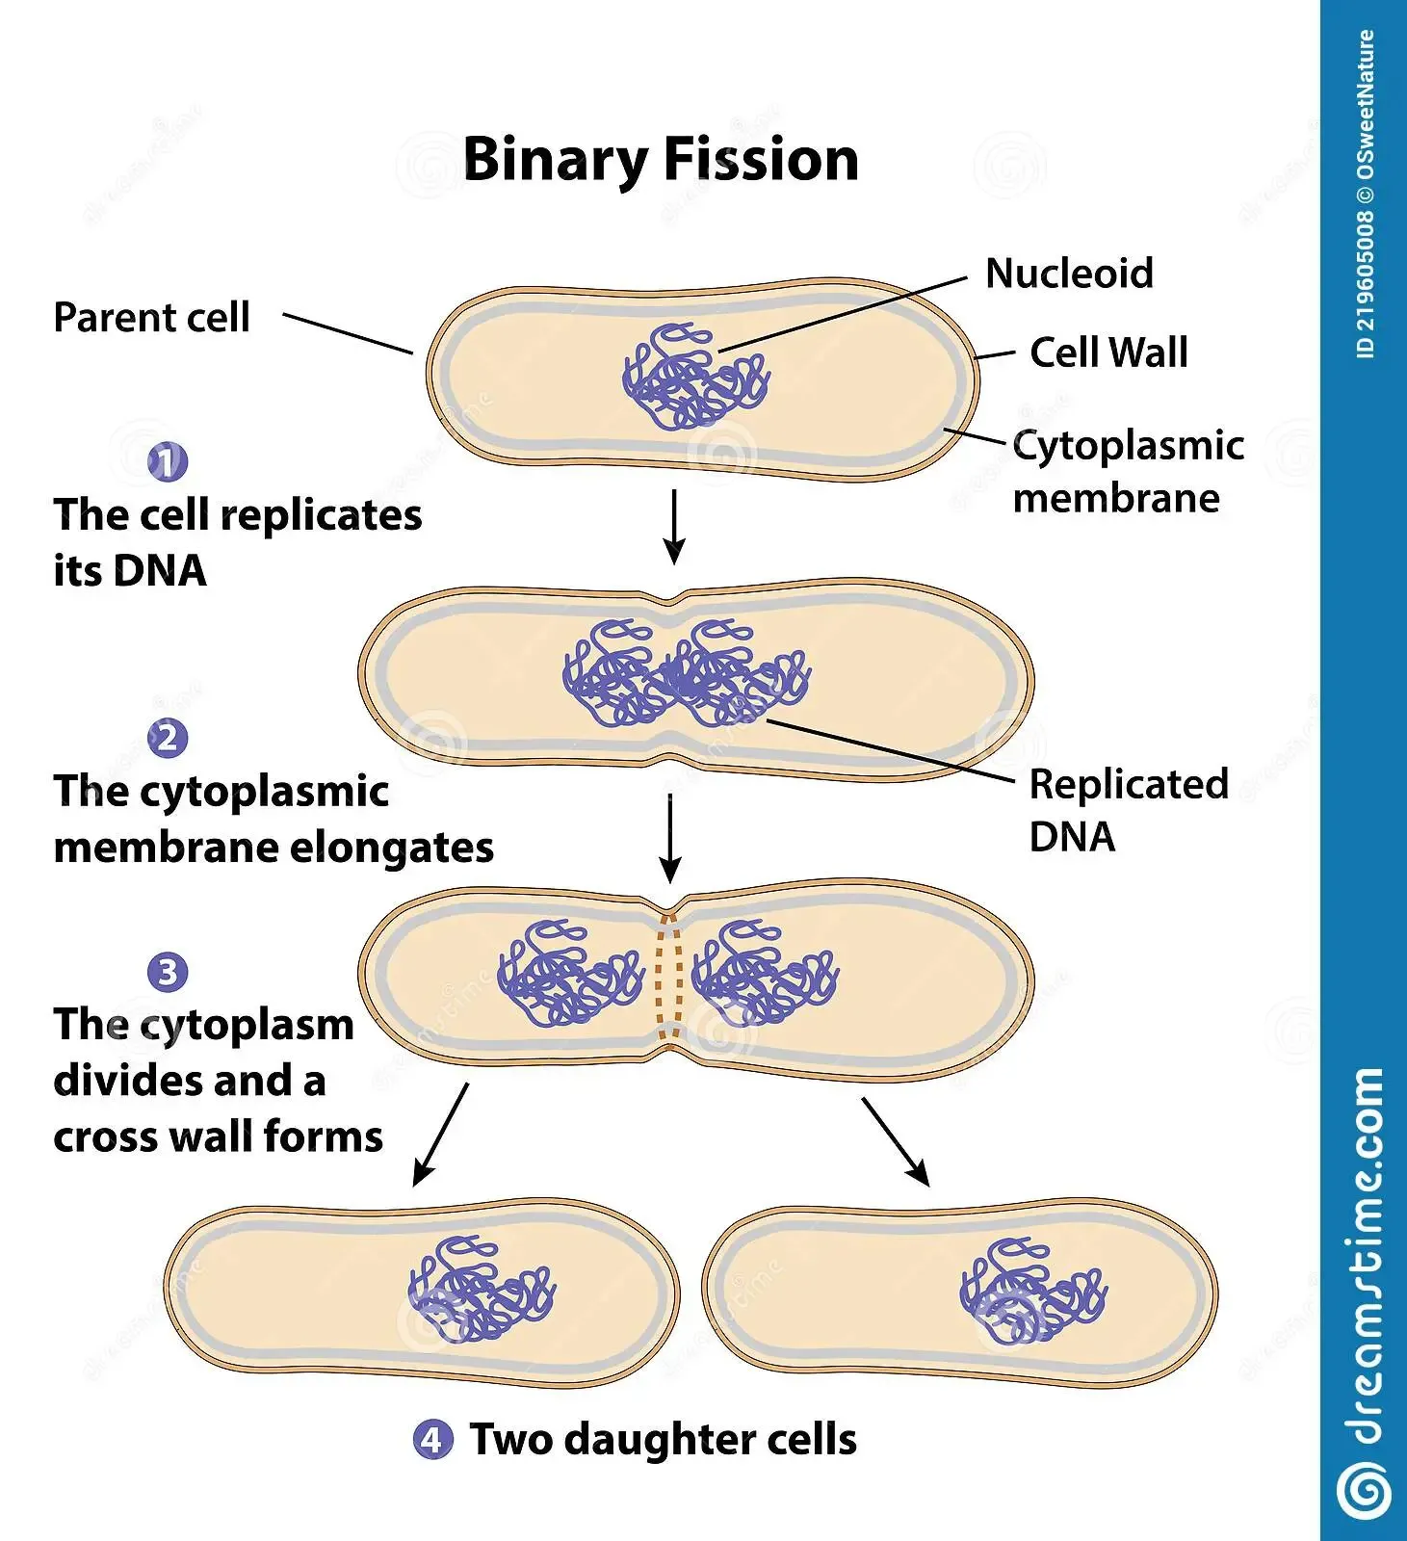

Binary fission is the simplest form of asexual reproduction, commonly observed in unicellular organisms such as bacteria and protozoa.

**Steps Of Binary Fission:**

1. The DNA of the parent cell replicates.

2. The two identical DNA molecules move to opposite ends of the cell.

3. The cytoplasm elongates and begins to constrict in the middle.

4. A transverse septum or cross wall forms.

5. The parent cell divides into two genetically identical daughter cells.

Important Note:

Although binary fission is common in microorganisms, no true multicellular plant reproduces by this method.

**9.1.2. Budding**

Budding is a form of asexual reproduction in which a new organism develops as an outgrowth or bud from the body of the parent.

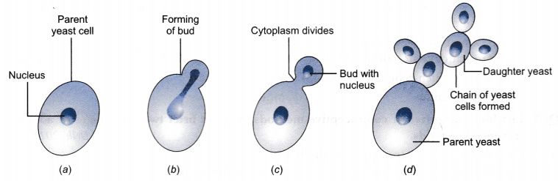

**Process Of Budding:**

1. A small protuberance or bud appears on the parent body.

2. The nucleus divides by mitosis.

3. One daughter nucleus migrates into the bud.

4. The bud grows in size and develops organelles.

5. The bud may detach to live independently or remain attached forming a colony.

**Example:**

• Yeast reproduces by budding.

• In higher plants, vegetative and floral buds give rise to new shoots and flowers respectively.

**9.1.2. Spore Formation**

Spore formation is a method of asexual reproduction in which microscopic, thick‑walled spores are produced inside special structures called sporangia.

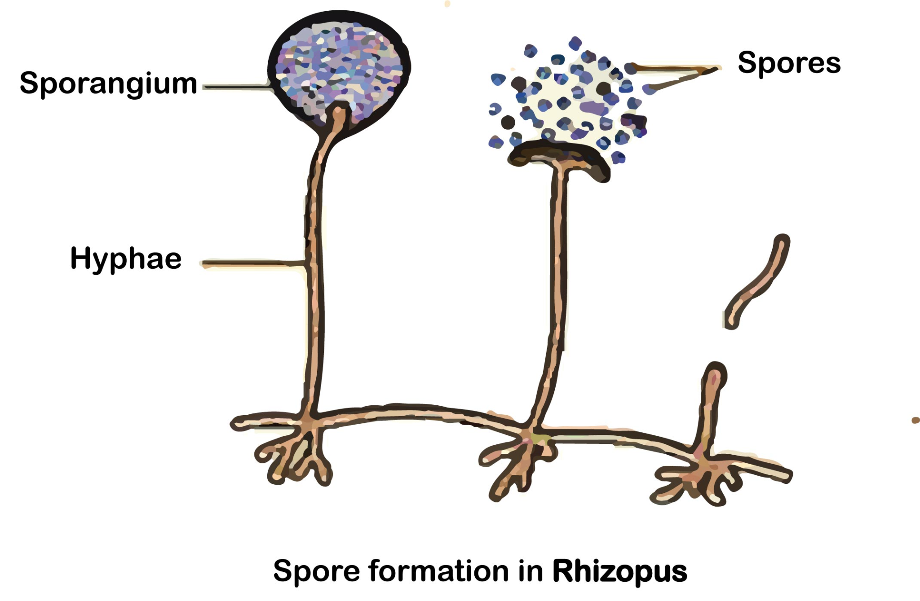

**Characteristics Of Spores:**

• Unicellular

• Non‑motile

• Thick‑walled

• Highly resistant to unfavorable conditions

**Process:**

1. The parent body forms sporangia at the tips of sporangiophores.

2. Cells inside the sporangium divide repeatedly.

3. Numerous spores are formed.

4. When mature, the sporangium bursts.

5. Spores are dispersed by air.

6. Under favorable conditions, spores germinate into new individuals.

Example:

• Rhizopus (bread mold)

**9.1.3. Parthenogenesis**

Parthenogenesis is the development of a new individual from an unfertilized egg cell. In plants, parthenogenesis is known as apomixis.

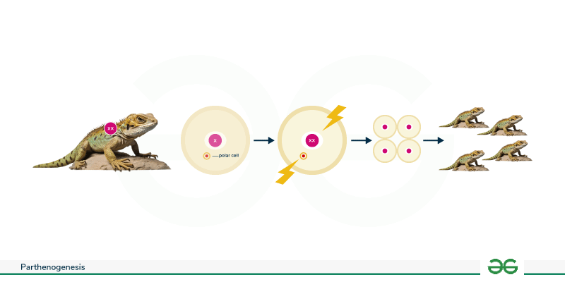

**Key Points:**

• Fertilization does not occur.

• Meiosis is absent.

• Offspring are genetically identical to the parent.

• Common in some flowering plants.

**9.1.4. Vegetative Propagation**

Vegetative propagation is a form of asexual reproduction in which new plants are produced from vegetative parts such as roots, stems, and leaves.

**Types:**

1. Natural vegetative propagation

2. Artificial vegetative propagation

**Methods of Natural Vegetative Propagation**

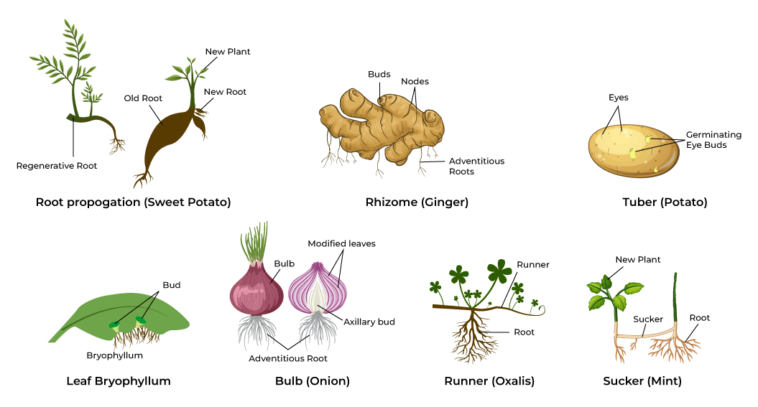

* Bulbs
  + Bulbs are underground, vertically growing modified stems surrounded by fleshy scale leaves that store food.
  + Examples: Onion, Garlic, Tulip
* Corms
  + Corms are short, solid, swollen underground stems that store food and help in perennation.
  + Example: Colocasia
* Rhizome
  + Rhizomes are horizontally growing underground stems with distinct nodes and internodes.
  + Example: Ginger
* Stem tubers
  + Stem tubers are swollen underground stems with eyes that develop into new shoots.
  + Example: Potato
* Stolon or Runners
  + Runners are long, slender horizontal stems that grow above ground and produce new plants at nodes.
  + Example: Strawberry
* Suckers
  + Suckers arise from underground parts and later develop into independent plants.
  + Example: Lawn grass
* Vegetative Propagation By Leaves
  + In Bryophyllum, adventitious buds develop along leaf margins and form new plantlets.

**Methods of Artificial Vegetative Propagation**

* Stem Cuttings
  + A portion of stem containing nodes is planted to grow into a new plant.
  + Example: Rose

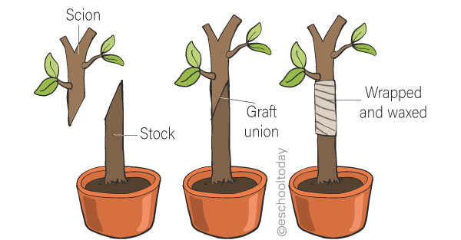

* Grafting
  + Grafting is a technique in which a scion is attached to a rootstock to combine desirable traits.
* Cloning (Tissue Culturing)
  + Cloning involves growing plant tissues on artificial nutrient media under sterile conditions.
  + Steps:
    - Selection of explant
    - Culture on nutrient medium
    - Formation of callus
    - Differentiation into plantlet
    - Transfer to soil

**9.2. Sexual Reproduction**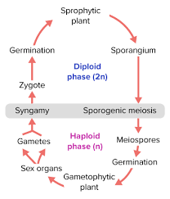

Sexual reproduction involves fusion of male and female gametes resulting in genetic variation. Sexual reproduction in plants, like animals, also involves the fertilization of gametes (eg and sperm) and formation of zygote and embryo. Different groups of plants, like bryophytes, pteridophytes, and seed plants (spermatophytes) have different mechanisms of gamete formation and fertilization.

In bryophytes and pteridophytes, the sperms are like little swimmers; they can move around and find the egg cells. So, they need water to do this. It could be dew or rain, but water is the key to their reproductive success.

On the other hand, seed producing plants (gymnosperms and angiosperms) have their own methods. They don't rely on water to get their sperm to the egg cells.

**9.2.1. Sexual Reproduction in Flowering Plants (Angiosperms)**

**Structure Of A Flower**

A flower consists of pedicel, thalamus, calyx, corolla, androecium, and gynoecium.

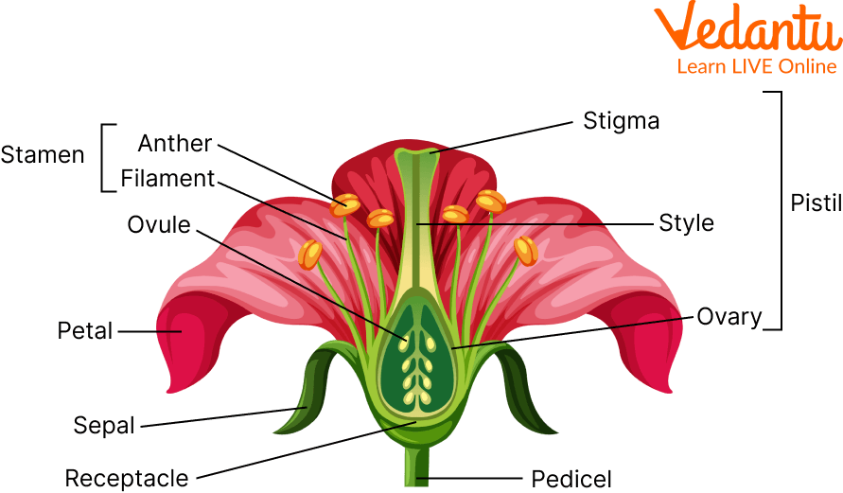

* Sepals (Calyx): Leaf-like structures, often green, that protect the flower bud before it opens.
* Petals (Corolla): Often brightly colored and scented to attract pollinators like insects or birds.
* Receptacle: The part of the flower stalk where the floral parts are attached.
* Pedicel/Peduncle: The stalk that supports the flower.
* Reproductive Parts (Essential Organs)
  + Male Parts (Stamen/Androecium)
    - Anther: Produces and contains pollen (male gametes).
    - Filament: A stalk that supports the anther.
  + Female Parts (Pistil/Carpel/Gynoecium)
    - Stigma: A sticky surface at the top that catches pollen.
    - Style: A tube connecting the stigma to the ovary, allowing pollen tubes to grow through.
    - Ovary: Contains ovules (female eggs) and develops into the fruit after fertilization, while ovules become seeds.

**Formation Of Microspores And Megaspores**

Microspores are formed in anthers by meiosis, while megaspores form inside ovules. The sequence is as follows:

* **Stamen** consists of a filament and a bilobed anther.
* **Anther** contains four pollen sacs that produce haploid pollen grains by meiosis.
* **Carpel (pistil)** has three parts: ovary, style, and stigma.
* **Ovary** contains one or more ovules.
* Each **ovule** has a spore mother cell that undergoes meiosis to form four megaspores.
* Only **one megaspore** remains functional.

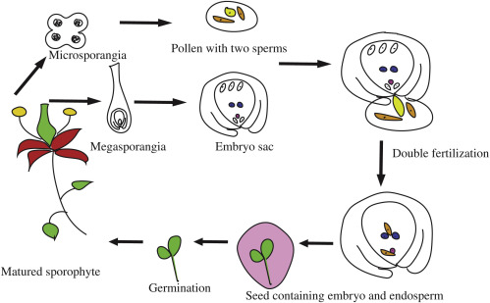

**Pollination**

Pollination is the transfer of pollen from another to stigma.

Types:

• Self pollination

• Cross pollination

Self-pollination is pollen transfer within the same flower/plant, ensuring trait preservation but less diversity, while cross-pollination moves pollen between different plants, boosting genetic variety for better adaptability, relying on agents like wind or insects but risking pollinator failure. Self-pollination creates identical offspring (homozygous) and is good when pollinators are rare; cross-pollination yields varied offspring (heterozygous) and maintains the gene pool, crucial for evolving, say saving the species.

**Formation Of Male And Female Gametophytes**

I. Development of Male gametophyte

Pollen grain germinates to form a pollen tube carrying two male gametes. The steps are as follows:

1. **Microsporogenesis (Meiosis)**
   1. Occurs in the anther's pollen sacs.
   2. Diploid Pollen Mother Cells (PMCs) undergo meiosis.
   3. Result: Four haploid microspores in a tetrad.
2. **Microgametogenesis (Mitosis)**
   1. Pollen Mitosis I (PMI): Each microspore enlarges and divides asymmetrically to form a large vegetative (tube) cell and a smaller generative cell.
   2. Cellular Differentiation: The vegetative cell forms the pollen tube, while the generative cell divides further.
   3. Pollen Mitosis II (PMII): The generative cell divides to produce two sperm cells (male gametes).
3. **Mature Pollen Grain**
   1. A typical mature pollen grain is a two-celled (or three-celled) structure containing the tube cell (which forms the pollen tube) and two sperm cells.
   2. The outer wall (exine) protects the gametophyte.

II. Development of Female gametophyte

Functional megaspore divides mitotically to form an embryo sac. The steps are as follows:

1. **Megasporogenesis (Spore Formation)**
   1. Megaspore Mother Cell (MMC): A diploid cell (2n) inside the ovule's nucellus divides.
   2. Meiosis: The MMC undergoes meiosis, producing four haploid (n) megaspores, typically in a linear arrangement (tetrad).
   3. Functional Megaspore: Usually, three megaspores degenerate, and only one (the functional megaspore) survives, usually at the micropylar end.
2. **Megagametogenesis (Embryo Sac Development)**
   1. Mitotic Divisions: The functional megaspore's nucleus divides three times by mitosis (karyokinesis) without immediate cytokinesis (cell division), resulting in eight nuclei.
   2. Nuclear Rearrangement: The nuclei organize into a distinct pattern within the embryo sac.
   3. Cell Formation (Cytokinesis): Cell walls form around most nuclei, creating a mature embryo sac (female gametophyte) with specific cells.
3. **Mature Embryo Sac Structure (Polygonum Type)** 
   1. Micropylar End:
      1. Egg Apparatus: One large egg cell (female gamete) flanked by two smaller synergids.
   2. Chalazal End:
      1. Antipodal Cells: Three haploid cells.
   3. Central Cell:
      1. A large central cell containing two polar nuclei, which often fuse to form a diploid secondary nucleus before fertilization.

**9.2.2. Seed And Fruit Formation**

After fertilization, the ovule becomes seed and the ovary becomes fruit.

**Structure Of Seed**

A seed's basic structure includes a protective seed coat, the embryo (baby plant with radicle for roots & plumule for shoot), and food storage (either cotyledons or endosperm), allowing dormancy and growth.

**Main Parts of a Seed**

* Seed Coat (Testa): The tough outer layer protecting the inner parts.
  + Hilum: A scar where the seed was attached to the ovary.
  + Micropyle: A tiny pore near the hilum for water/oxygen entry.

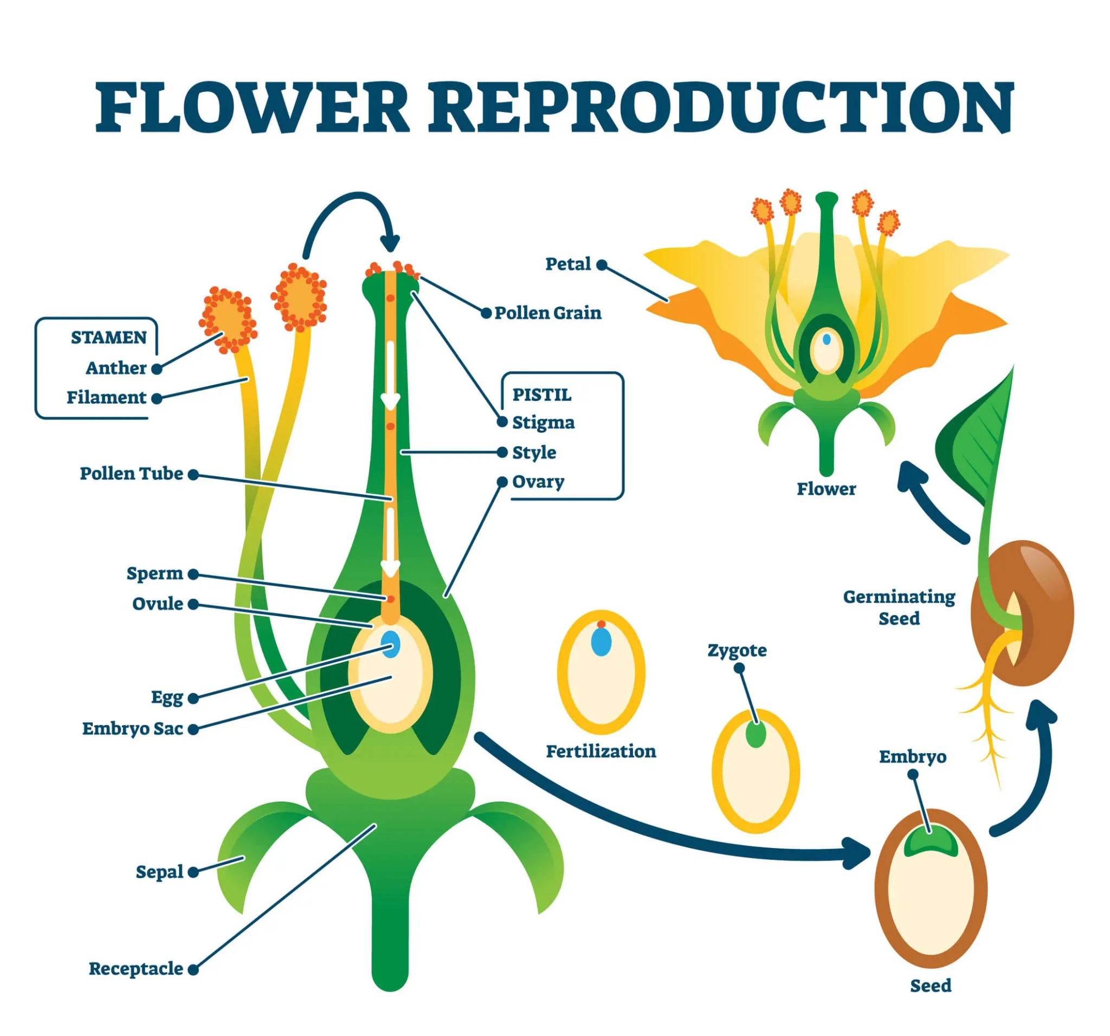

* Embryo: The miniature plant.
  + Radicle: Develops into the primary root.
  + Plumule: Develops into the shoot (stem and leaves).
  + Hypocotyl/Epicotyl: Connects cotyledons to plumule/radicle.
* Food Storage: Nourishes the embryo.
  + Cotyledons: One (monocots) or two (dicots) seed leaves storing food.
  + Endosperm: Nutritive tissue, often bulky (like in corn) or absorbed by cotyledons (like in beans).

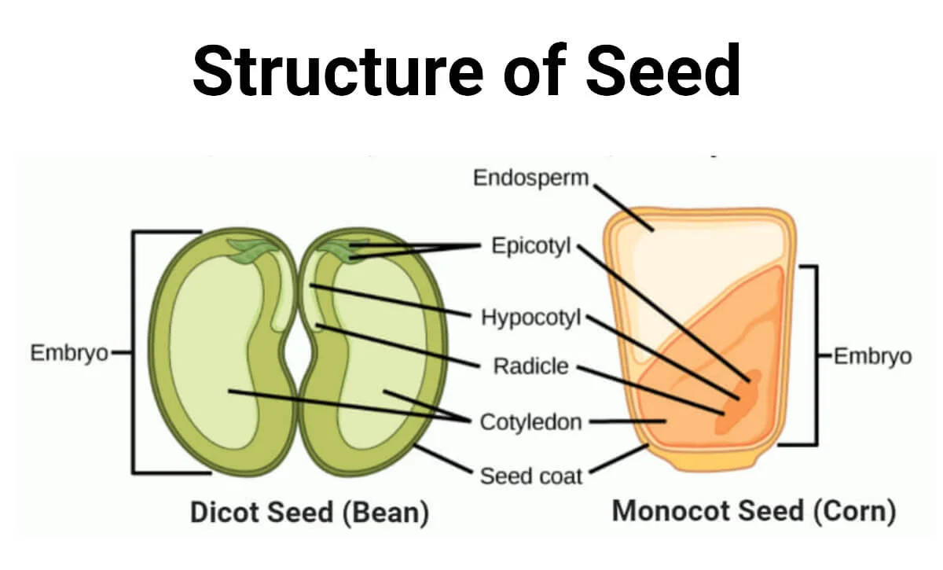

**9.2.3. Seed Germination**

**Epigeal Germination**

Cotyledons come above the soil surface.

Example: Bean

**Hypogeal Germination**

Cotyledons remain underground.

Example: Pea

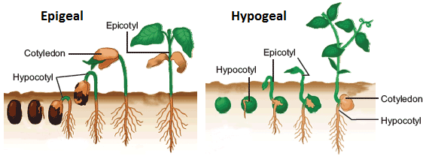

**Conditions for Seed Germination**

* Water (Moisture): Softens the seed coat and activates enzymes, initiating cell enlargement (imbibition).
* Oxygen (Air): Needed for respiration to produce energy (ATP) for cell division and growth.
* Temperature: Must be suitable for the specific species; too hot or cold slows or stops growth.



